FLAME TREATMENT BURNER GROUP D-6
RANGE: HIGH VELOCITY, MONOPLEX, DUPLEX

Introduction

This burner is applied mainly in flame plasma surface treatment of plastic components prior to painting. It is specially designed to generate high velocity flames for high speed flame treatment when mounted on multi axis robot manipulators. Its light weight body, through ‘wrist’ small bore connections, multiple flame zone construction and protected ignition electrode ensure reliable, flexible and fully programmable flame treating of car bumper bars, mouldings and complex shapes in continuous production processes.
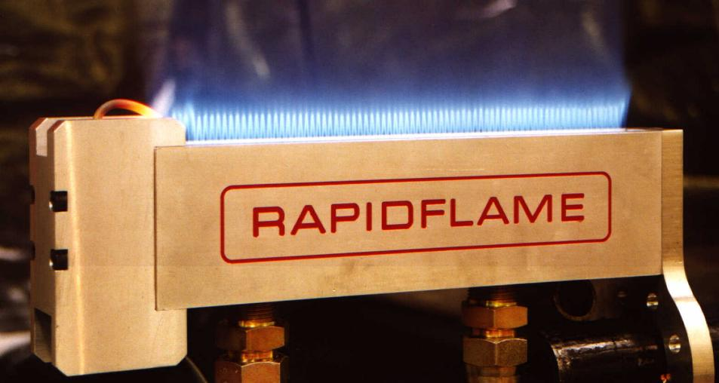

Specification

Designed to operate with compressed air and natural or LP gas, duplex (two zone) and monoplex (one zone) burners are manufactured from aluminium with special flame port patterns for seamless multi zone operation with a high velocity flame. Burners are fitted with a customer specified robot arm connection flange.

Air-gas connections are at the back of the burner body and burners can be supplied complete with light weight connecting fittings and small bore hoses for connection to the burner control system.

Complete air–gas mixing control panels, including residual oxygen level and firing rate control systems for each zone can be supplied with this burner (see data sheet V-3, V-4). The Ignition - flame sensing electrode can be mounted in an optional casing for greater protection or side mounted.

Zone B and C dimensions can be specified on order to suit product shape

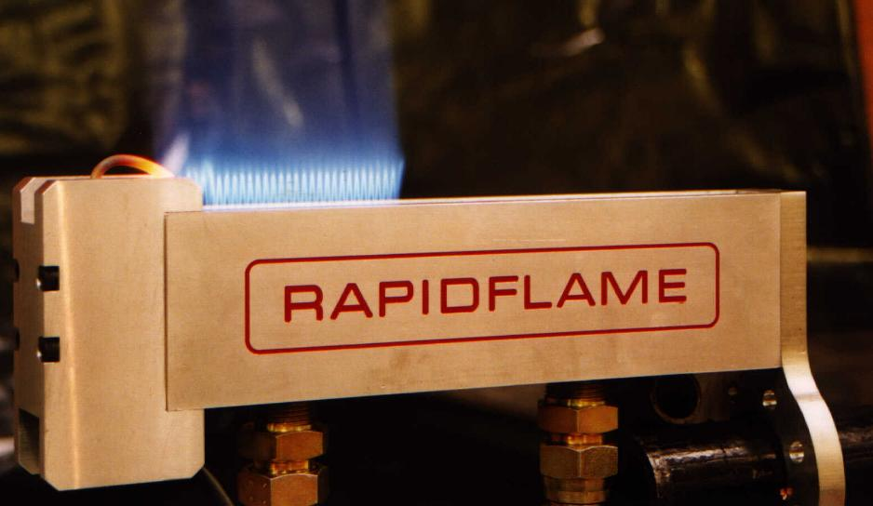

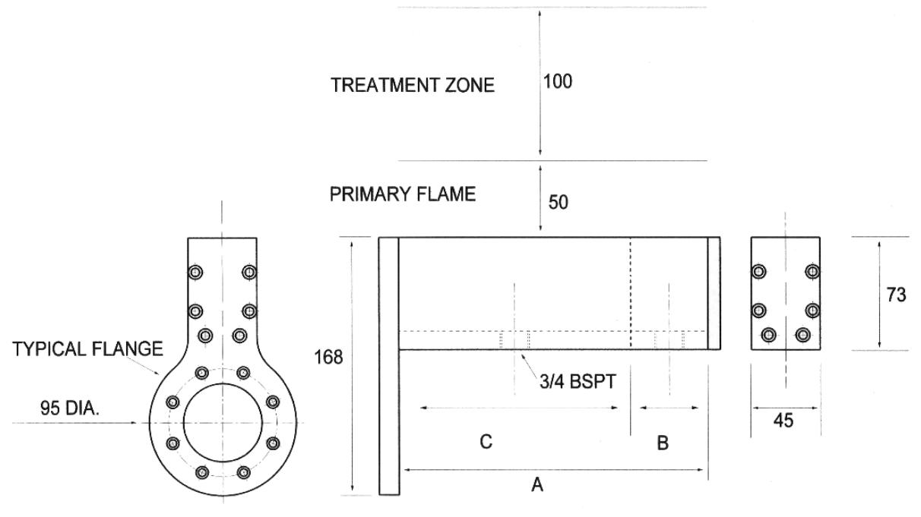

Catalogue # | Part # | A mm | B mm minimum | C mm maximum | Rating Kcal/hr
 | D-6-40 | 40 | - | - | 6,500.00
 | D-6-60 | 60 | - | - | 10,000.00
 | D-6-100 | 100 | - | - | 16,000.00
D-180 | Monoplex 150-M | 150 | - | - | 25,000.00
D-182 | Monoplex 200-M | 200 | - | - | 34,000.00
D-184 | Monoplex 250-M | 250 | - | - | 42,000.00
 | D-6-280 | 280 | - | - | 46,000.00
D-186 | Monoplex 300-M | 300 | - | - | 50,000.00
D-181 | Duplex 150-D | 150 | 50 | 100 | 25,000.00
D-183 | Duplex 200-D | 200 | 50 | 150 | 34,000.00
D-185 | Duplex 250-D | 250 | 50 | 200 | 42,000.00
D-187 | Duplex 300-D | 300 | 50 | 250 | 50,000.00

All gas safety equipment or products must be installed and used in full compliance with applicable safety standards and Industry codes of practice. Consult Rapidflame sales department for advice if in doubt.

